~Network Thread and Mitigation & Physical Security and Risk:
- Create a table listing 5 common network threats (such as phishing, DDoS, man-in-the-middle, malware, and password attacks), and for each, write one real-world example from an app or service you use (like WhatsApp, Instagram, or Paytm).

Network Threat | Real-World Example
Phishing | Fake Paytm login page steals user credentials.
DDoS Attack | Instagram becomes slow or unavailable due to massive fake traffic.
Man-in-the-Middle (MITM) | Public Wi-Fi intercepts WhatsApp login traffic.
Malware | Malicious app steals data from your phone and social media accounts.
Password Attack | Hacker tries multiple passwords to access an Instagram account.

- Simulate a brute-force attack scenario by writing a simple Python script that tries to guess a 4-digit PIN code by checking all possible combinations against a preset value.<br><br><em><strong>Constraint:</strong> The script should print the number of attempts it took to guess the correct PIN.</em>

</>Python
# Preset 4-digit PIN
correct_pin = "4825"

attempts = 0

for i in range(10000):
guess = str(i).zfill(4) # Converts 5 to "0005"
attempts += 1

if guess == correct_pin:
print("PIN Found:", guess)
print("Attempts:", attempts)
break

Sample Output:
PIN Found: 4825
Attempts: 4826

-This script simulates a brute-force attack in a controlled educational setting by trying every 4-digit PIN from 0000 to 9999 until it finds the correct one, then prints the number of attempts.

- List 4 physical security risks that could affect a server room hosting a popular app like Zomato or BookMyShow, and suggest one mitigation step for each risk.

Physical Security Risk | Description | Mitigation Step
Unauthorized Access | An unauthorized person may enter the server room and steal or damage equipment. | Use biometric authentication, keycard access, and maintain an access log.
Fire | Electrical faults or overheating can cause a fire, damaging servers and causing data loss. | Install smoke detectors, automatic fire suppression systems, and fire extinguishers.
Power Failure | A power outage can shut down servers, interrupt services, and corrupt data. | Use UPS systems and backup generators to provide continuous power.
Theft or Physical Damage | Servers or networking equipment may be stolen or intentionally damaged. | Install CCTV cameras, lock server racks, and employ 24/7 security personnel.

- Draw a simple floor plan (hand-drawn or digital) of a small office and mark at least 3 physical security measures you would implement to protect network equipment (such as CCTV, biometric access, or cable locks).

The is online generated diagram of floor plan:

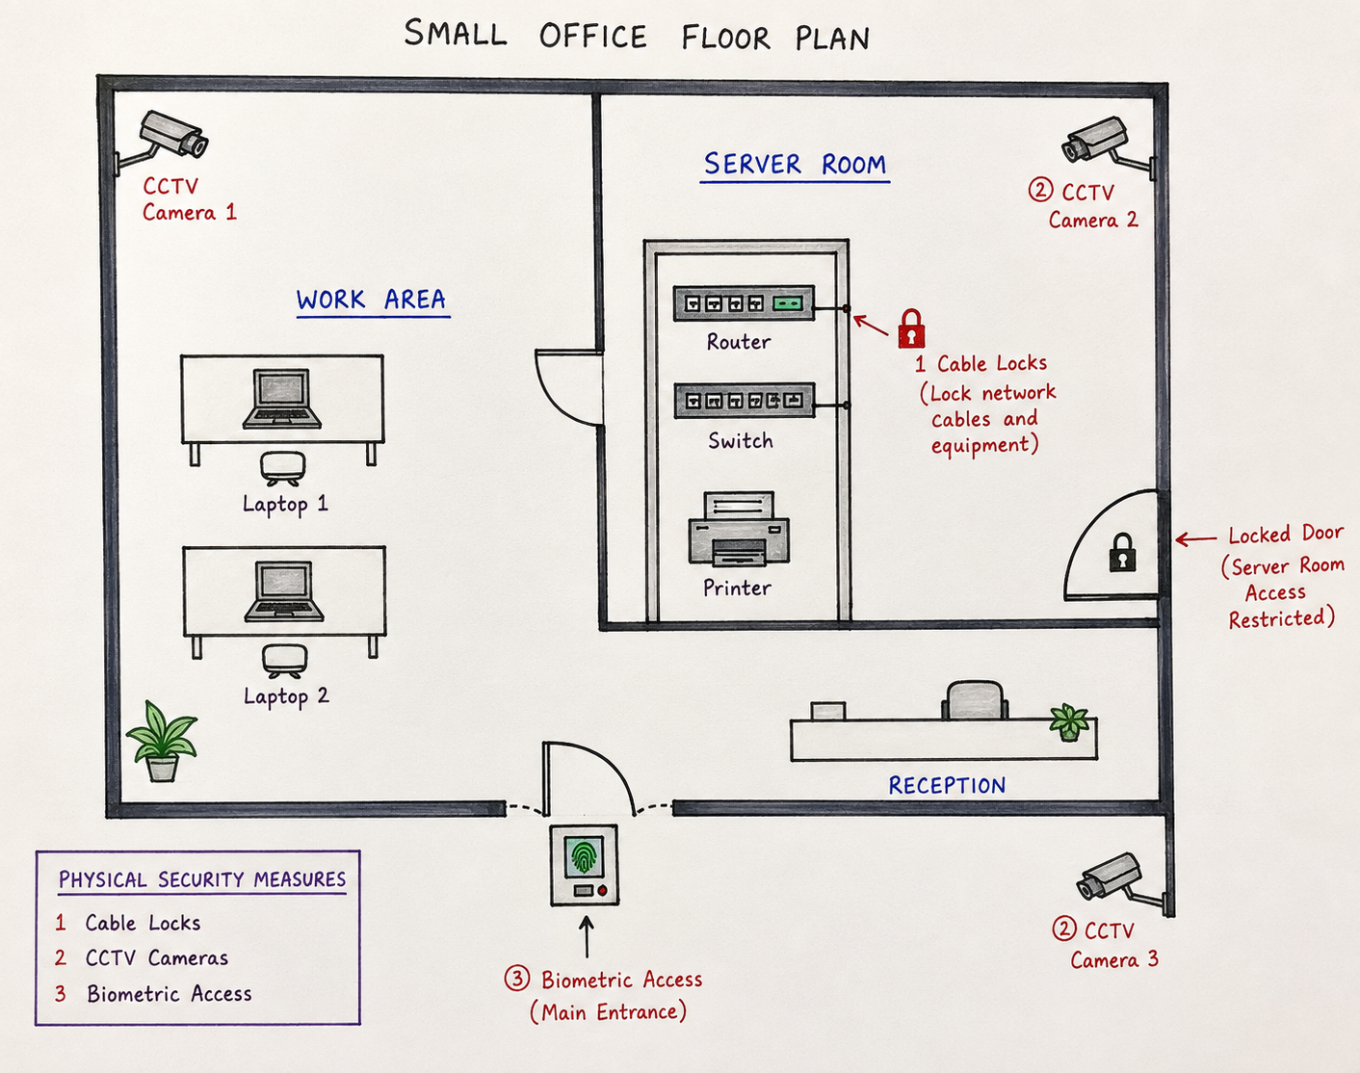

Physical Security Measures
- Biometric Access at the main entrance – Only authorized employees can enter.
- CCTV Camera monitoring the office and server room – Records all activities and deters intruders.
- Cable Locks / Locked Server Rack – Prevents theft or tampering with network devices such as the router, switch, and printer.
This layout satisfies the requirement of marking at least 3 physical security measures in a small office floor plan.

- Use ChatGPT or a similar AI tool to generate a checklist of 7 actions a network admin should take to mitigate risks from both network threats and physical security breaches, then review and edit the checklist to make it specific for a college computer lab environment.
Checklist for Securing a College Computer Lab:
- Use strong passwords and enable multi-factor authentication (MFA) for administrator accounts.
- Keep all computers, routers, and antivirus software updated with the latest security patches.
- Configure firewalls to block unauthorized access and allow only required network traffic.
- Install antivirus software on every computer and perform regular malware scans.
- Restrict physical access to the server room and networking equipment using locks or biometric access.
- Install CCTV cameras to monitor the computer lab and protect systems from theft or unauthorized use.
- Back up important data regularly and train students to recognize phishing emails and other cybersecurity threats.
This edited checklist is specifically designed for a college computer lab, combining protection against both network threats and physical security risks.

THE END…….

